202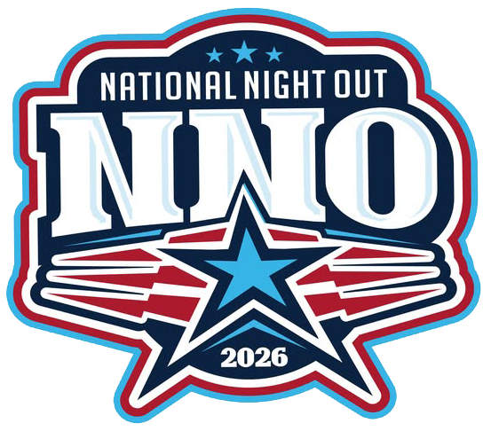
CRESTWOOD POLICE NATIONAL NIGHT OUT

DATE: AUGUST 4, 2026
TIME: 5:30 p.m. to 8:30 p.m.
PLACE: WALKER PARK
13900 S. LARAMIE AVENUE CRESTWOOD, IL 60418

Gates Open at 4:30 PM for Vendors
Business Name: __________________________
Contact Name & Phone number: _____________________________________
Email: ______________________________________________
TABLE _________
CHAIRS _________
ELECTRICITY NEEDED YES / NO ______
DETECTIVE ART RONAN AT; aronan@crestwood.illinois.gov
ADMINISTRATIVE ASSISTANT AT; ooslakovich@crestwood.illinois.gov

